28th Annual Festival Regatta
SUNDAY June 27th, 2010
Part of the Merrimack River Summer Sprints
in conjunction with the Lawrence Celebration Regatta
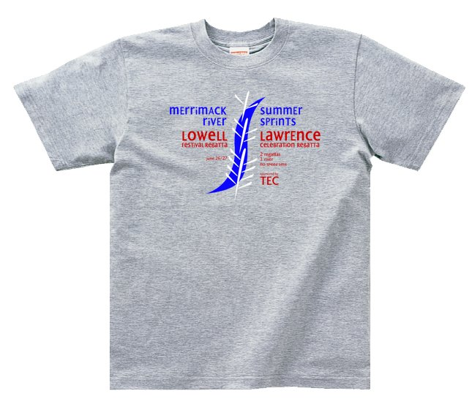
Welcome to the 28th Annual Festival Regatta brought to you by the members of the Merrimac River Rowing Association. The MRRA is very proud of this fun day of 6-lane sprint racing on the scenic and historic Merrimac River in Lowell, Massachusetts. This regatta features about 30+ events for the full range of age and boat classes and is being run in conjunction with the Lawrence Celebration Regatta the day before.
This packet contains only important race-day information. Please refer to the web site before coming to the regatta for updated news and information about the regatta.

We hope you enjoy the day. If you have any questions, please write to the regatta directors at: festival@merrimackrowing.org

Sincerely,

Ginny LaFreniere & Tim Wheatley
Festival Regatta Directors

GENERAL NOTES
- Please launch at least thirty (30) minutes prior to your scheduled race time. Boats launching have priority over boats docking. If you are hot-seating or sharing equipment, notify the dock master and have all equipment and rowers ready to switch quickly.
- NOTICE that the travel lane to the START is on the launch side of the river. Use caution when rowing to the start line or from the finish line and stay to the side of the river away from the racing lanes. There is no need to cross the river or the race course. Be safe!
- All races are 1000m and are FINALS ONLY (no heats).
- The MRRA Concessions Committee will have food and beverages available for sale somewhere in the immediate vicinity of the boathouse. Registration is done through Regatta Central, and race-day check-in is done at the boathouse. Check-in is required.
- Motor boats may travel the travel lane between races at head way speed. Please no wake! Your cooperation is greatly appreciated by the competitors.

FAQ
- Is Check-In required? – YES -- CHECK-IN IS REQUIRED AT THE BOATHOUSE PRIOR TO RACING. The desk will be open from 6:00am through 1:30pm on Race Day. All rowers must check in at least one hour prior to the start of your race.
- Is there food available during the day? Yes, The Concessions Committee will be in the vicinity of the boathouse.
- I have two races scheduled too closely. Can I change my heat times? There are no heats, races are FINAL ONLY.
- Are there medals? Yes, medals are awarded for 1st place.
- Who won? Please see the Race Results Board outside the boathouse or check the web site on Monday.
- Where are the finish times posted? Please see the Race Results Board.
- Where do I go to find if there are any spare Coxswains? Check at the Registration Desk. We have no formal process but will keep a list of names and phone numbers upon request.
- Are there heats? Where do I find my lane assignments? No heats, all races are FINAL races. See Events Schedule Board on the side of the boathouse. A few days prior to the regatta you will be able to check the website for lane assignments.
- Can I get a copy of the full race results? Yes, the race results will be posted online at the MRRA website at www.merrimackrowing.org shortly after the event.
- Where are the restrooms? Off the main hall by the deck near registration.
- Will jet-skis and power boats be a problem? No, We have Environmental Police boats at the Start and Finish areas to limit and control boat traffic.

AREA MAP

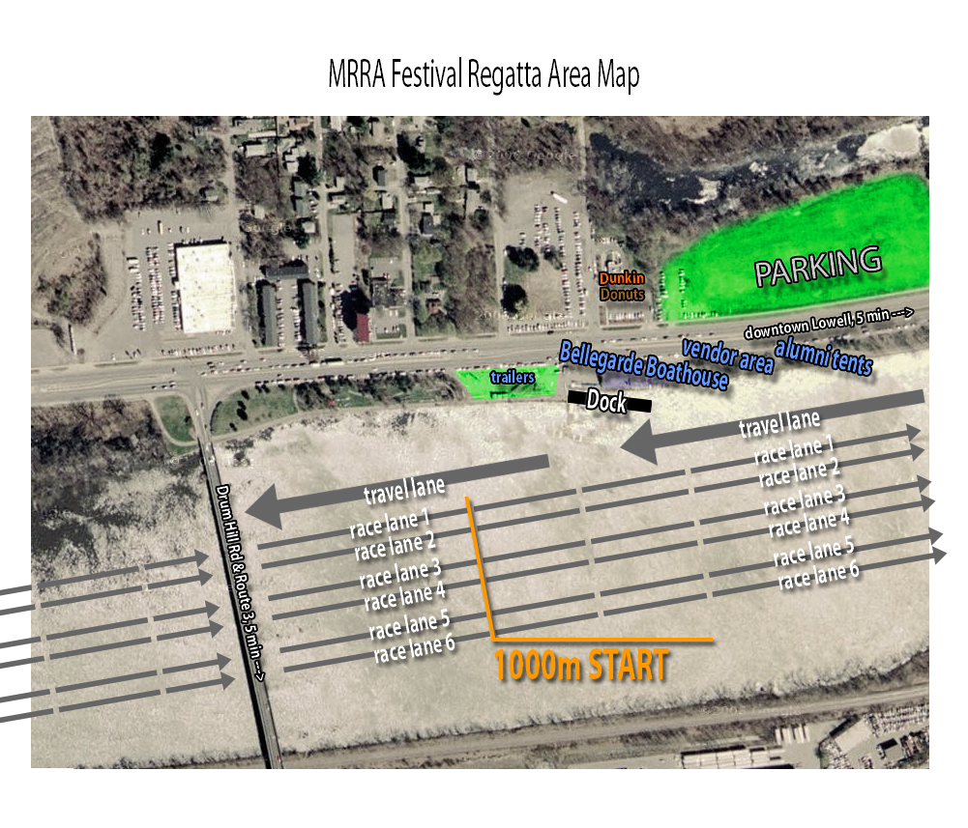

COURSE MAP
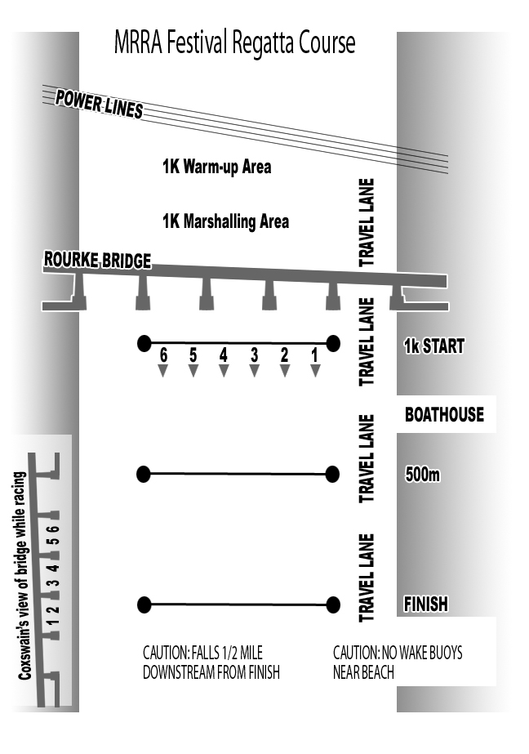

RULES

Race Category Definitions:
Age is age as of race Day.
- Novice: First year of rowing
- Junior: 18 years old or less
- Master: 27 - 39 years old
- Senior: 40 - 49 years old
- Veteran: 50-59
- Veterans 60-69
- Veterans 70-79
Mixed events: equal number of male and female rowers in boat, coxswain either gender

Rules & Regulations for Coxswains & Strokes
Before The Race:
Launch & Warm-up:
- Check in with beach or dock master or control commission; if there is a problem, report it at once and write down the official's name to which you reported the delay.
- Recheck bow number one last time; make sure bow ball is O.K.
- Carefully follow normal warm-up pattern.
- Watch your watch constantly.
- Be very conscious of races on the course; stop to let them pass if you are near them to avoid a warning
- Follow traffic pattern religiously
The Race:
At the Start:
- Be at the starting area 5-8 minutes before race if possible; do not play mind games at the start--get there with time to spare and focus
- If possible, listen to starter's voice and cadence for previous race to get a sense of how he will call yours.
- Know the various starting commands.
- Check in with referee or marshal; identity yourself and race; this is very important in large regattas;
- Be locked on to stake boats with three minutes to go; get sense of wind at start
- Get your point and target; compensate for wind or current in keeping point; if there is a long delay, know where to keep your point to compensate for winds
- On raising hands: --- vigorously wave bow hands only
- Check position of your rudder especially after you have backed in
- Know exactly how to scull bow around; check on where you want blades depending on current/wind
- Acknowledge any warnings from starter
- Remember, the movement of the flag starts the race not the voice of the starter
Lateness & False Starts & Breakage:
- If you are late and permission has been given, don't panic your team on getting to the line
- False starts: kinds of alignments; misleading other crews; backing down and your rudder
- Not ready at the start
- Breakage time or buoys
- Stopping a race in the zone
The Body of the Race:
- Lanes: know your own and others on buoyed and non-buoyed courses and when are you out of your water
- Interference and fouls; leaving your lane; others leaving theirs
- Referee commands and flags: white and red flags.
- Steering and over - steering
The Finish of the Race:
- Make dead sure you have crossed the line; finish buoys or flags are usually beyond the line
- What five things the referees need to do at the finish: safety, weights, time, look for protests, certify race with white flag.
- Checking your athletes health; lying down in the boat
- Knowing when to leave the finish
- Filing a protest on the water
- Withdrawing a protest
- Meaning of the flags
After The Race:
Filing a Protest:

- If and only if you have given verbal notification on water to the referee of your race, a signed written form of the protest must follow within hour of your reaching land stating the problem and remedy sought. There is a $25 protest fee.
- Jury will accept, reject, order a new race, or order a change in the finish order.

