MRRA Club Secretary
Membership Accounting Quick Guide
Contents
Overview 2
Paperwork Management 2
Update member paperwork 3
Membership Financial Accounting 4
Reports 7
Membership Billing 7

Note
This and other How-To documents are posted on the MRRA web site here:
http://www.merrimackrowing.org/how-to

Overview
There are a few membership maintenance tasks performed by the club Secretary that help to keep track of members, their paperwork requirements, payments/credits, etc. Most of the tasks are performed directly on the MRRA website. The club Secretary has a certain “Admin” level of security that grants him/her access to the necessary functions, while keeping them hidden from regular members.

Paperwork Management
Log in to the MRRA website using your standard login. The Super Admin (Carl) has set your security level in two places that lets you:
- Create and edit website articles (Not discussed in this document).
- Manage membership
Visit the My Membership link:
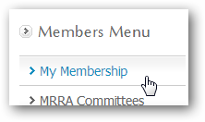
Anyone with Admin access will see a person selector at the upper right:
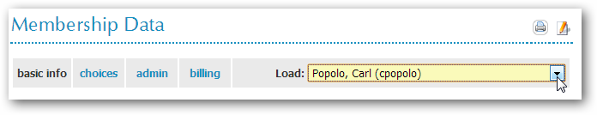
Ordinary members do not have this “load” feature to access member records other than their own. Herein lies the Admin power – you can access the record of any member (or non-member) and edit their record as if you were logged in as that person.

Here is a task-oriented list of the things you might do with this feature:

Update member paperwork
- Load a person using the selector. The screen will refresh with the data for that person.
- Switch to the “admin” tab
- In section 4, update the members Swim Certificate date if they are required to provide that to the MRRA.
- In section 5d, check all the boxes that apply for the person as their paperwork is received.
- Item #2 is the USRowing Waiver which each person does individually online. Check with Wilma on how to download the report so that you can update this field – there is no automatic link from USRowing to our website.
- Is this person a member? Membership in the MRRA has never been something that we could fully automate; it’s always up to the club Secretary to decide this. If a person’s paperwork and payments are “complete enough”, you check this box and that is the first of two signals that allows the member to be a valid member and row. A person checked here is considered part of the membership counts on many other reports.
- Okay to Row? In some cases, someone may be marked as Okay to Row yet not be a member. Example: LTSWEEP and LTSCULL folks who pay to row in various MRRA programs are not considered members. Another example: Coxswains who we hire to work the sweep programs – they are not members, but we want their data in our system so that we can plan resources when scheduling rowing events, etc. Coaches are typically both Members and Ok2Row – we simply credit their payments (shown below) so that they are not obligated to pay to be members.
- Under Miscellaneous is the very rarely used ability to permanently delete a person’s record. We do this rarely because it’s not unusual for a member to take a time off from the MRRA but then return mid-year or in a subsequent year. So we don’t typically delete records here, but you can if you must. A better example of the need to delete a record is when a person has accidentally created two records – every person should have only one record, so typically you would delete the record with the lesser information and avoid the confusion of having two records for one person.
- Click SUBMIT at the bottom of the page after updating sections 4 or 5D, and you’ll see a success message after the changes are saved.

Membership Financial Accounting
Using the same “load” feature, load a person who has handed you a check for membership or program fees, or needs some kind of credit. You keep track of the member finances in a way where every in or out of dollars is a separate transaction.
Members make program “choices” which puts an amount due into their records. You relieve these amounts due by posting payments or credits against their account.
New in 2013: Many payments will be automatically posted to a member account via back-office antics with PayPal. This is a major timesaver for the club secretary, I’m only sorry we didn’t get it done sooner for Wilma.
The bottom line here is that every member’s accounting show balance out to zero come hell or high water, sooner or later. You enter payments and credits to get to net zero; if there is no way to zero an account, then that usually means someone owes us money. The Secretary gets to decide that, and you can send out an automatic bill in those cases, or write your own email to the member.
How To:
- With the correct member “loaded” into your view, click the “billing” tab.
- Study the picture below. For the most part, you are seeing exactly the same things that an ordinary member sees when they click their own billing tab. The main exception is that you have the power to enter transactions on this screen in the yellow boxes.
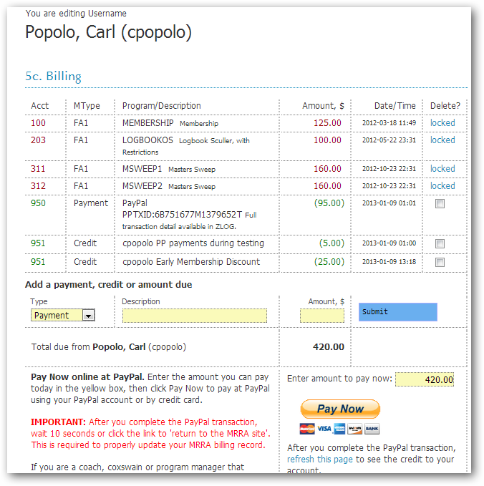

- Note in the example above that Popolo has previously made program “choices” which put a total of $545 in red – the amounts due – into his account. The Secretary didn’t put them there – the member did when he or she made program choices.
- In green you’ll see the reliefs against the payments. In theory, sometime around year end, the red amounts and the green amounts should offset, and the member is at net zero.
- There are several types of things you can enter into the yellow boxes, and by way of example:
  - Member hands you a check at a meeting. Choose PAYMENT, enter a description (usually the Check Number) and the amount. Click SUBMIT to refresh the page and update the amount due.
  - Member says they are a coxswain for MSWEEP and shouldn’t have to pay for the MSWEEP program choice. The MSWEEP program manager will approve this, and you can issue a CREDIT for the full or partial amount according to what the Program Manager approved (don’t ever just take the member’s word – always get approval from someone with the right to waive costs). Another typical example is when someone joins mid-program and we issue a credit for a partial use of the program.
  - AMOUNT DUE is used when you want to put an amount due into the member record but it’s not something automatic from member “choices”. E.g., private sculling lessons may be offered but are not an official MRRA program, yet the MRRA may be paying the coach. So you might enter an AMOUNT DUE of $100 for “Extended Coaching” or something like that.
To recap: There are three types of amounts you can put into a members financial record; two are reliefs which reduce their amount due, and one is designed to increase the amount due.
- The Admin also has the power to make program “choices” on a member record! Keep this in mind – you can always go to “choices” and fix a member’s record. Example: Last year, Linas took LTSCULL1 and LTSCULL2, but this year he will just row as a sculler and doesn’t need those two choices on his record. He should be fixing those choices for himself – but the reality is that many people won’t bother. At the end of the day, it’s probably easier for you to fix their record when you clearly know the intent of the member. This will help you balance their account and get to net zero.
- Other things on the billing screen: A record becomes “locked” after a certain amount of time when we no longer allow the member to eliminate the choice. E.g., a member cannot remove their choice for MSWEEP during the last week of the MSWEEP program – that wouldn’t be very fair. Once a record is locked, the member can’t undo that choice, so they cannot undo the obligation to pay for it. Admin, however, can unlock a record and delete it if necessary (rarely). If you made an incorrect entry, just check the “delete” box for that entry and click SUBMIT to poof the record.
- REGARDING PAYPAL (NEW FOR 2013):
  - Right now, when a member pays with PayPal, a confirmation is sent to paypal@merrimackrowing.org, and I have been keeping these. I will soon have them sent to the secretary@ as well.
  - Until I complete some additional work, it is very possible that the member paid with PayPal but closed the PayPal session before it had a chance to update the MRRA records. Please follow this process when you see a notification from PayPal that we have received a payment:
    - The PayPal notice will tell you the name of the person who made the payment.
    - “Load” that person and go to their “billing” tab.
    - Check to see that there is a PayPal transaction that coincides with the email you received.
    - If not, make a manual PAYMENT entry. Use the PayPal Transaction ID for the description, preceded with “PPTXID:” and enter the amount reported by PayPal. When done correctly, you should see something like this after you SUBMIT the manual entry:
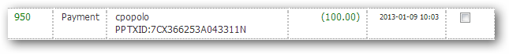
Your username will appear in the description so that we know who made the entry.
This entire discussion above should be moot sometime soon when I complete the PayPal work, but it’s worth mentioning here just in case there are other conditions where PayPal transactions don’t flow through automatically. The email from PayPal is a notification of a firm payment to our PayPal account, so we want to be sure the member record is always in sync with those transactions. If you see “cpopolo” as in the above example, that simply means that I beat you to the punch and made the adjustment already.

I will give you the login credentials for PayPal next time we’re together in person. Once I get some info from the Treasurer, I will update the PayPal account to automatically transfer money to the MRRA bank account.

Reports
There are a variety of reports of various worth. I’m going to stick to those that are currently supported and may even be enhanced; there are others that I’m looking to phase out.
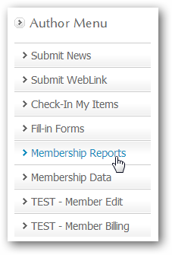
Most reports are intended for on-screen consumption but some look fine when printed.

Membership Billing
Click on “Membership Reports” from the Authors Menu.
Click on “Billing-Members”.
This report most closely aligns with the data you see when you use My Membership and “load” to work with a member’s record. Everything you did on My Membership should be reflected here.
You can click on any member to open their details.
You can click the “SEND BILL” button to send the detail to the member – along with a personal message of your own. We’ve stopped short of creating a monthly batch process to send bills out to all members, but that’s not off the table just yet.
There’s one giant disconnect with what you see in the Billing-Members report. Given that most members don’t get around to making their program choices until March or later, you aren’t going to see an accurate list of program choices in this view of the data. The view of the data in January is really only useful to see who has paid their membership early in order to take advantage of the discount. Compounding this problem, we don’t even know pricing for the program fees at this point. So it’s not a good time of the year to badger members into making their program choices – until we have firm prices. Given this, you are likely to see many members showing “overpaid” because they have paid their $100 for membership but have not yet touched their choices. (When they make their choices and SUBMIT, their choices are added to their billing records and will then start to appear on this screen). For those members who have made “choices”, they are likely to show on this report as “Owes” and that’s simply because we’ve only asked them to pay the $100 membership fee here in January.
More to come…

