MRRA How to Post Committee Meeting Minutes on the Website

Note
This and other How-To documents are posted on the MRRA web site here:
http://www.merrimackrowing.org/how-to

Overview
This article describes how to post a meeting minutes on a committee page on the MRRA website. This document is really a subset of instructions found in the Post an Article document and is intended for committee members who simply want to post a PDF into an existing page on the web site.
You must be logged in to the MRRA website at www.merrimackrowing.org, and the site administrator must have granted you “author” permissions.

Process

- Prepare in advance: Create a PDF from your Word document – meeting minutes should be posted as PDF. IMPORTANT TIP: Name your documents with the following format:
YYYYMMDD-MRRA-(committeename).PDF. Do not use month names in the file name – use the two digit month number.
Why? All committee documents, and most other website documents are all stored in a common folder. By naming documents with the date as the leading portion of the filename, documents are easier to find because they will tend to be chronologically grouped together. This is not a hard rule, but the webmaster will not be very sympathetic when someone says that documents are difficult to locate after they have been uploaded to the server.
- What committee are you on? Locate the web page that has already been created for your committee which shows all meeting minutes that have already been previously posted. You will be editing this page to upload your PDF of meeting minutes. Locate the page as follows (we’re using general club meeting minutes in this example):
  - Click MRRA Committees in the left menu to expand the list of committees
  - Click your committee
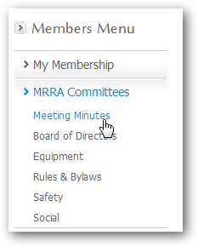
  - Locate the article (there may be several for your committee) which contains the bullet list of meeting minutes.
  - Click the Edit icon to the upper right
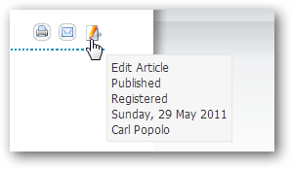
- You’re now in the edit mode for the article. Position your cursor where you wish to insert the PDF you will upload. Press enter if you want to insert a new bullet line.
- Type the text that you want to see on the article:
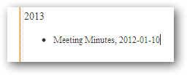
- Swipe the text to target for a hyperlink
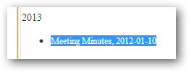
- You will now upload the PDF that should be targeted when someone clicks the text you have swiped:
  - Click the LINK button
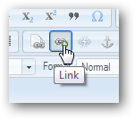
  - From the Link dialog, click BROWSE SERVER
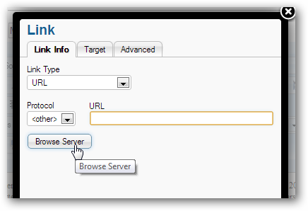
  - Click CHOOSE FILE to select the PDF (or Excel or Word doc) from your computer to upload it to the website
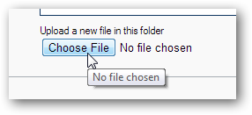
  - Click SEND IT TO THE SERVER to upload the file
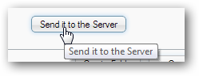

  - Now locate the uploaded file from the folder and click it to insert the URL into the LINK dialog box.
Result:
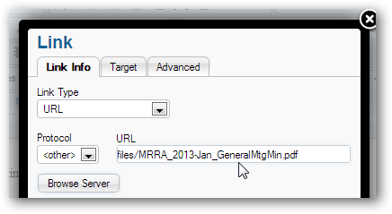
  - Choose the TARGET tab in the LINK dialog and set the Target to “New Window”. This will cause the PDF to open in a new browser (desired) when the visitor clicks the link to view the PDF.
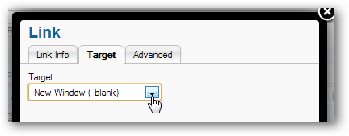
  - Click OK. You should see that the text you swiped to target the link is now showing as blue or underlined text, signifying that it is a hyperlink.
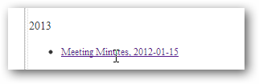

- Back at the top of the form, click SAVE to publish the article.
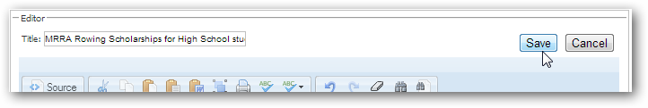
- Verify that your changes have been saved. When you click the link to the new meeting minutes, the PDF you uploaded should open in a new browser window. If it doesn’t repeat the edit process starting in step 2d above. If you can’t make it work, ask for help – but be specific with where you are hung up. carl@merrimackrowing.org

The Article with your Meeting Minutes is Updated – Now What?
After you have published an article, there are various ways you may publicize it:
- Do Nothing – the article is on the website, and visitors will see it when they come to the home page (if you set the Publish to Front Page = Yes).
- You can reference the new article in another article.
- You can reference the article in a club e-mail that you will send to the members.
IF YOU ARE A COMMITTEE MEMBER – DO NOT SEND E-MAIL TO THE ENTIRE CLUB TO ANNOUNCE YOUR MEETING MINUTES ARE POSTED. Instead, send an email to the Club Secretary and s/he will include your announcement in the next club-wide email s/he sends.
Steps:
- Decide the context of how you will publicize the article:
  - If you will tell people to just “visit the website”, then simply reference www.merrimackrowing.org and they will trip over your new article.
  - If instead you want to send them directly to the article, note the URL of the article – click on the article title, and the URL will be shown in your browser location box:
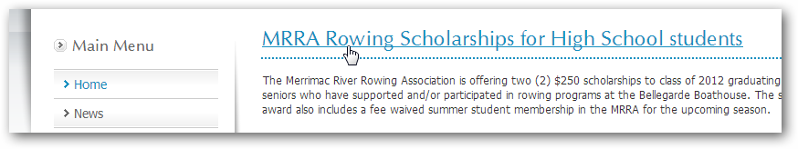
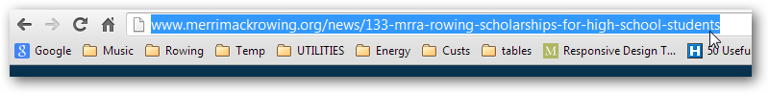
  - Copy and paste the URL into the new article or e-mail.
- To reference the article in a new article, swipe some text in the new article, click the LINK button and set the LINK parameters – change the protocol to http and set the URL to the URL you copied above in 1c.
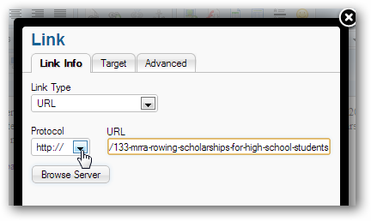
- To reference the article directly in an e-mail, just paste the URL into the email:
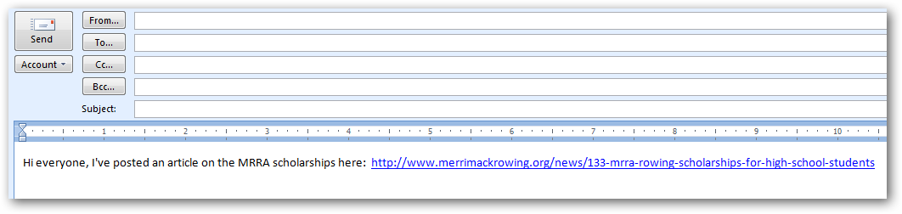
- You can also send people directly to the PDF you have uploaded, but in general it’s better practice to send them to the article where they can then view the PDF, rather than send them directly to the PDF. The article is where you can frame and set context for one or more links to PDF files, so referencing a single article is always better than including several PDF links in an email.

END

