MRRA How to Post an Article on the Website

Note
This and other How-To documents are posted on the MRRA web site here:
http://www.merrimackrowing.org/how-to

Overview
This article describes how to post a new article on the MRRA website, and how to include a PDF or image into the article.
You must be logged in to the MRRA website at www.merrimackrowing.org, and the site administrator must have granted you “author” permissions.

Process
- If you will be posting a link to a document and have the document as a Word file, you should generally convert the Word file to PDF. Word has a Save As PDF option. The only time a Word document should be posted in Word format is if the document will need to be downloaded and edited by visitors to the web site, otherwise it’s best practice to upload documents in PDF format.
- Select the menu option “Submit News” from the Author Menu
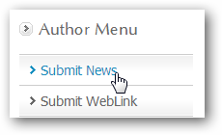

- Fill in the form. In general, it’s not a good idea to Copy/Paste directly from Word because the Word formatting can screw up the look of the article as seen in a web browser. If you do Copy/Paste from Word, then be sure to click the “remove formatting” button after posting the content.
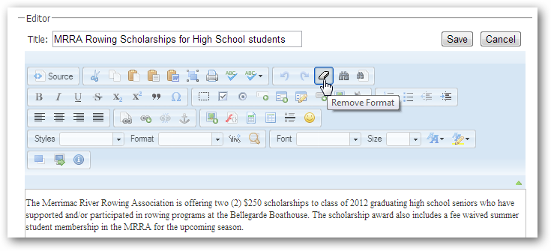
Do not add excessive formatting to the article. Do not color text red unless it’s really urgent, and don’t resize text to be really big or small. If you wish to include paragraph headlines, use the FORMAT box and choose H2 or H3. The text set to H2 or H3 will be bigger and bolder, so use those sparingly, and keep the text brief.
TIP: If your article is long, include a “Read More” link after the first paragraph. This will keep the article brief on the home page, but allow the visitor to read more by clicking the link. This keeps the home page from growing very large because of a few lengthy articles. To insert a read more, put your cursor where you want to break the text, and click the Read More button at the bottom of the article editor:
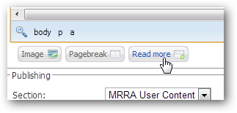

- To add a link to a PDF:
  - Type the text that should be linked:
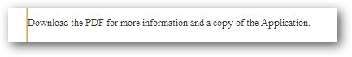
  - Swipe the text that should be linked
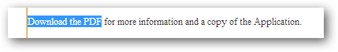
  - Click the LINK button
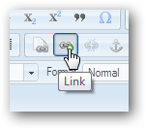
  - From the Link dialog, click BROWSE SERVER
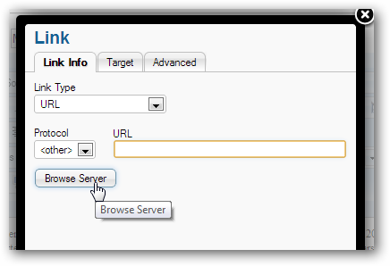
  - Click CHOOSE FILE to select the PDF (or Excel or Word doc) from your computer to upload it to the website
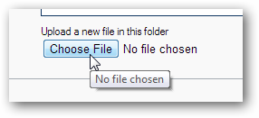
  - Click SEND IT TO THE SERVER to upload the file
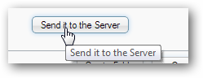

  - Now locate the uploaded file from the folder and click it to insert the URL into the LINK dialog box.
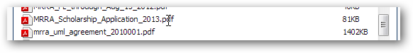Result:
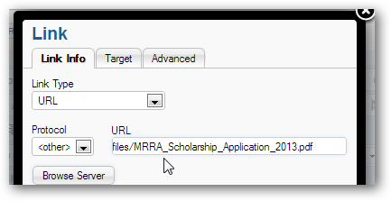
  - Choose the TARGET tab in the LINK dialog and set the Target to “New Window”. This will cause the PDF to open in a new browser (desired) when the visitor clicks the link to view the PDF.
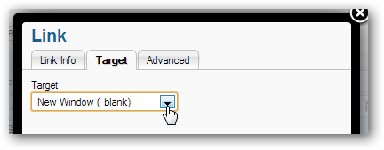
  - Click OK. You should see that the text you swiped to target the link is now showing as blue text, signifying that it is a hyperlink.


- When you are done editing the article content, set the following options in the Publishing section:
  - For general homepage visibility, choose Section = MRRA User Content and Category = MRRA News. For documents that should be grouped with a particular committee (but may also appear on the home page), choose Section = MRRA Committees and for the Category choose the appropriate committee.
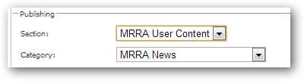
  - Set Published to Yes, and optionally set Show On Front Page to Yes.
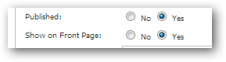
  - Set Start Publishing to today’s date if it is not already showing as the default. Set the Finish publishing to:
    - Leave Blank if the article should live forever
    - Set a finish publishing date if you want to expire the article after a certain date. For example, the MRRA Scholarship article should disappear sometime in June after the scholarships have been awarded.
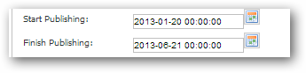
  - Access Level: Leave “Public” if all visitors can view the article. Set to “Registered” if the article only applies to MRRA Members. They will need to login to see the article. This is useful to keep our internal membership articles from being visible to the general public, e.g., Meeting Notices, club commentary, etc. Do not choose Special.
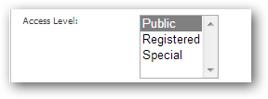
  - Ordering can be ignored; Articles on the site are automatically ordered based on their creation date.

- Back at the top of the form, click SAVE to publish the article.
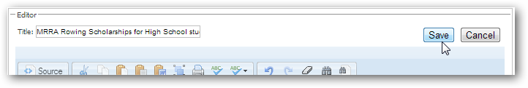
- Verify that the article is published. If you set the article to Public access, logout to see that the article is visible when you are not logged in. If you set the access to Registered, you should see the article without the need to logout first. Remember that if you said Yes to publish on the Front Page, the article should appear at the top of the page. If it doesn’t check the dates you set on the article. Verify that any links you set open correctly.
- To edit the article after you have already posted it, click the Edit icon that shows when you are logged in as an Author:
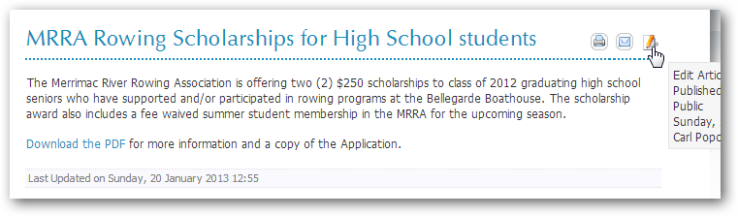

The Article is Published – Now What?
After you have published an article, there are various ways you may publicize it:
- Do Nothing – the article is on the website, and visitors will see it when they come to the home page (if you set the Publish to Front Page = Yes).
- You can reference the new article in another article.
- You can reference the article in a club e-mail that you will send to the members.
Steps:
- Decide the context of how you will publicize the article:
  - If you will tell people to just “visit the website”, then simply reference www.merrimackrowing.org and they will trip over your new article.
  - If instead you want to send them directly to the article, note the URL of the article – click on the article title, and the URL will be shown in your browser location box:
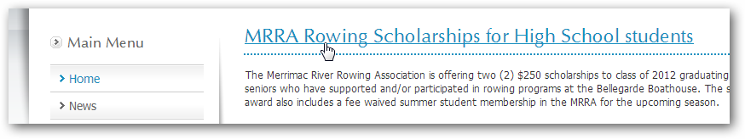
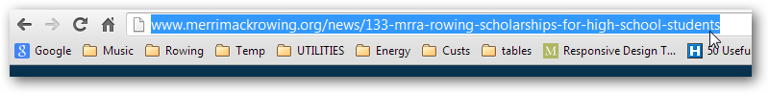
  - Copy and paste the URL into the new article or e-mail.
- To reference the article in a new article, swipe some text in the new article, click the LINK button and set the LINK parameters – change the protocol to http and set the URL to the URL you copied above in 1c.
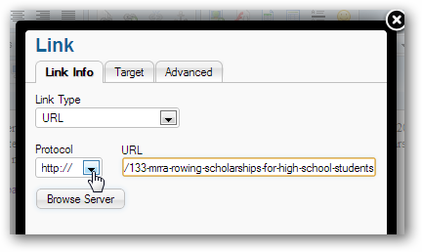
- To reference the article directly in an e-mail, just paste the URL into the email:
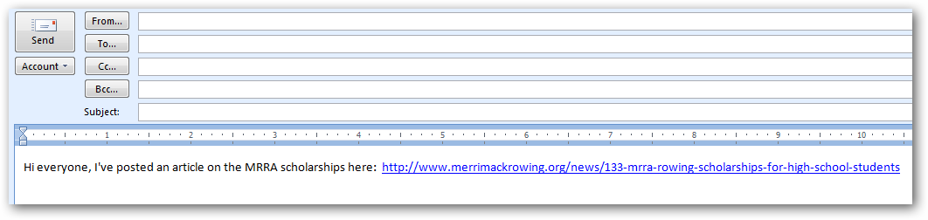
- You can also send people directly to the PDF you have uploaded, but in general it’s better practice to send them to the article where they can then view the PDF, rather than send them directly to the PDF. The article is where you can frame and set context for one or more links to PDF files, so referencing a single article is always better than including several PDF links in an email.

END

